Business Rules
1-
One or more employees must work in one department.
one department must contain many employees.
2- 
One or more employees must work in one branch.
one branch must contain many employees.
3- 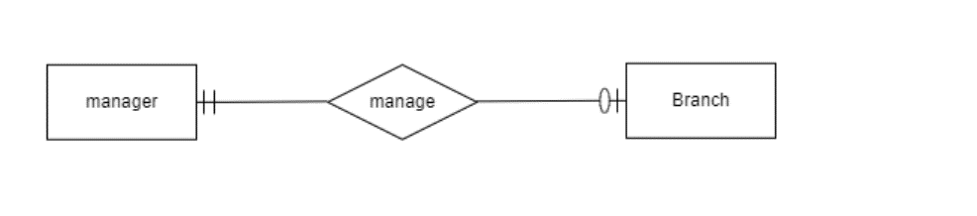
One manager may manage one branch.
one branch must be managed by one manager.

4- 
One employee may manage one or many employees.
one or more employees must be managed by one employee.
5- 
One manager may manage one Department.
one department must be managed by one manager.
6- 
One branch must handle many Accounts.
many Accounts must be handled by one branch.

7- 
One Customer must has one or many Accounts.
one Account must be owned by one customer.

8- 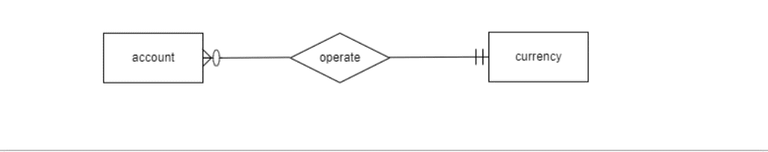
One or more Accounts must be operated by one currency.
one currency may operate one or more accounts.

9- 
One Account must has one Card.
one card must be owned by one account.

10- 
One customer must has one or more Card.
one card must be owned by one customer.

11- 
One card may make one or more transaction.
one or more transactions must be done by one card.

12- 
One ATM must make one or more transaction.
one transactions must be done by one ATM.

13- 
One customer may take one or more loan receipt.
one loan receipt must be taken by one customer.

14- 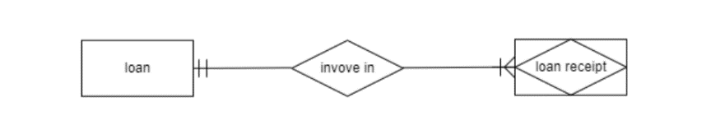
One loan must be involved in one or more loan receipt.
one loan receipt must include one loan.

15- 
One manager may approve one or more loan receipt.
one loan receipt must be approved by one manager.

16- 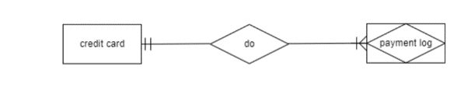
One credit card must do one or more payment record.
one or more payment record must be done by one credit card.
17- 
One loan receipt must do one or more payment record.
one or more payment record must be done by one loan receipt.

